|  |  |
| --- | --- |
| **EX NO:1** | **Write the complete problem statement** |
| **DATE** |

**AIM:**

To prepare a PROBLEM STATEMENT for a Mind Care Platform.

**ALGORITHM:**

* The problem statement is the initial starting point for a project.
* A problem statement describes what needs to be done without describing how.
* It is generally a one-to-three-page document that all project stakeholders agree upon, describing the goals of the project at a high level.
* The problem statement is intended for a broad audience and should be written in non-technical terms.
* It helps both technical and non-technical personnel communicate effectively by providing a clear description of the problem.
* The problem statement does not describe the solution to the problem.

**INPUT:**

* The input to requirement engineering is the problem statement prepared by the customer.
* It may include an overview of the existing system and the broad expectations from the new system.
* The first phase of requirements engineering begins with requirements elicitation, i.e., gathering information about the requirements.

Here, requirements are identified with the help of the customer and existing system processes.

**Problem:**  
 The traditional approach to mental health care is often fragmented, inaccessible, and stigmatized, making it difficult for individuals to seek timely support. People frequently lack personalized tools to monitor their mental health, access professional help, or engage with resources in a user-friendly manner. These challenges exacerbate the growing mental health crisis, leaving many without adequate care and increasing the societal burden of untreated mental illness.

**Background:**  
 The concept of digital mental health management platforms has evolved in response to the need for accessible and holistic solutions. Traditional methods, such as in-person therapy or static self-help resources, are often limited by cost, availability, and stigma. Leveraging advancements in digital health technology, modern platforms integrate features like mood tracking, appointment scheduling, resource sharing, and feedback systems. These platforms aim to provide personalized and proactive mental health support, catering to diverse user needs and breaking barriers to care.

**Relevance:**

A mental health management platform like Mind care is increasingly relevant in a world where mental illness impacts millions. By offering accessible tools to monitor well-being, connect with professionals, and access curated resources, Mind care addresses critical gaps in mental health care. Its digital-first approach reduces stigma, ensures timely support, and fosters self-awareness, making mental health management more inclusive and effective in today's technology-driven era.

**Objectives:**

The objective of the Mind care Platform is to create a comprehensive digital solution for managing mental health by:

1. Enhancing Accessibility: Providing an easy-to-use platform that allows individuals to access mental health resources, track their mood, and book appointments anytime and anywhere.
2. Promoting Self-Awareness: Empowering users to monitor their mental health through personalized mood logs and progress tracking, enabling proactive management of their well-being.
3. Reducing Stigma: Offering a discreet platform to seek mental health support, thereby addressing the societal stigma associated with traditional mental health care.
4. Facilitating Professional Support: Connecting users with mental health professionals through a streamlined appointment system for timely intervention and guidance.
5. Centralizing Resources: Providing a curated library of mental health resources such as articles, videos, and self-help tools tailored to individual needs.
6. Encouraging Feedback and Improvement: Enabling users to provide feedback on services, ensuring continuous improvement and a user-centric approach.
7. Promoting Emotional Well-being: Sending personalized notifications and reminders to encourage regular check-ins and foster a healthier mental state.

**Result:**

|  |  |
| --- | --- |
| **EX NO:2** | **Write the software requirement specification document** |
| **DATE** |

**AIM:**

To do requirement analysis and develop Software Requirement Specification Sheet(SRS) for Mind Care Platform.

**ALGORITHM:**

SRS shall address are the following:

a) **Functionality.** What is the software supposed to do?

b) **External interfaces.** How does the software interact with people, the system‘s hardware, other hardware, and other software?

c) **Performance.** What is the speed, availability, response time, recovery time of various software functions, etc.?

d) **Attributes.** What is the portability, correctness, maintainability, security, etc. considerations?

e) **Design constraints imposed on an implementation.** Are there any required standards in effect, implementation language, policies for database integrity, resource limits, operating environment(s) etc.?

**1. Introduction**

* **1.1 Purpose:**The SRS defines the requirements of the Mind care Platform, serving stakeholders like developers, managers, and users. It aims to provide a secure, user-friendly system for mental health management through tools like mood tracking, resource access, and professional support.
* **1.2 Scope:**The platform offers functionalities such as user registration, mood logging, resource library, appointment scheduling, feedback collection, notifications, and secure data management to enhance mental health care accessibility and efficiency.
* **1.3 Definitions, Acronyms, and Abbreviations:** **SRS**: Software Requirements Specification

**UI/UX**: User Interface/User Experience

**GDPR**: General Data Protection Regulation

* **1.4 References:**GDPR and HIPAA for data protection
* Mental Health Act (India)
* **2.2 Product Features:**The Mind care Platform is a standalone system that integrates user interfaces, resource libraries, and secure databases, aligning with modern healthcare frameworks.
* **2.3 User Classes and Characteristics:** **Users**: Access tools and resources for mental health.

**Professionals**: Manage appointments and services.

**Administrators**: Oversee platform operations and security.

* **2.4 Operating Environment:**

Web and mobile apps for Windows, Android, and iOS, with cloud-based backend for scalability..

* **2.5 Design and Implementation Constraints:**Compliance with data protection laws (e.g., GDPR, HIPAA) and standards for mental health services
* **2.6 Assumptions and Dependencies:**Requires reliable internet, third-party APIs (if needed), and user cooperation for data input.

**3. System Features:**

**3.1 Feature 1: User Registration and Authentication**

Description: Secure registration and authentication for users and professionals.  
Functional Requirements: User registration with personal details, password-based authentication, optional two-factor verification, role-based access control.

**3.2 Feature 2: Mood Tracking and Logging**

Description: Track and visualize mood trends.  
Functional Requirements: Mood input via scales or notes, mood graphs and insights, trigger tracking, resource suggestions.

**3.3 Feature 3: Appointment Scheduling**

Description: Book sessions with mental health professionals.  
Functional Requirements: Calendar-based scheduling, availability checks, appointment notifications, online/in-person preferences.

**3.4 Feature 4: Security and Privacy**

Description: Protect user data and prevent unauthorized access.  
Functional Requirements.

**4. External Interface Requirements**

* **4.1 User Interfaces:**User-friendly, accessible interfaces with dashboards, mood tracking, and appointment booking. Features include text resizing, screen reader compatibility, and clear navigation.
* **4.2 Hardware Interfaces**

The platform runs on standard devices (PCs, smartphones, tablets) and may support future biometric or health tracking devices.

* **4.3 Software Interfaces**

Interfaces with calendar APIs (e.g., Google Calendar), authentication APIs (OAuth), email services (e.g., SendGrid), and data analytics tools (e.g., Google Analytics**).**

* **4.4 Communication Interfaces**

Secure communication over HTTPS with SSL/TLS encryption for privacy and data protection**.**

**5. System Attributes**

* **5.1 Performance Requirements**

The system should handle at least 1,000 concurrent users with response times under 2 seconds. It must support real-time mood logging and appointment scheduling, processing user data efficiently with minimal delay.

* **5.2 Security Requirements**

The system must use encryption for data storage and transmission (e.g., AES, TLS). It should include audit trails for user activities, multi-factor authentication, and protection against cyberattacks (e.g., DDoS mitigation, firewall).

* **5.3 Reliability**

The platform should have 99.9% uptime, with automated backups every 24 hours. It must handle hardware failures without data loss and support quick recovery from errors.

**5.4 Availability**

The system must be available 24/7, especially during high usage periods, with downtime not exceeding 1 hour per month for maintenance and updates.

**result**

**SAMPLE OUTPUT:**

**ER DIAGRAM:**

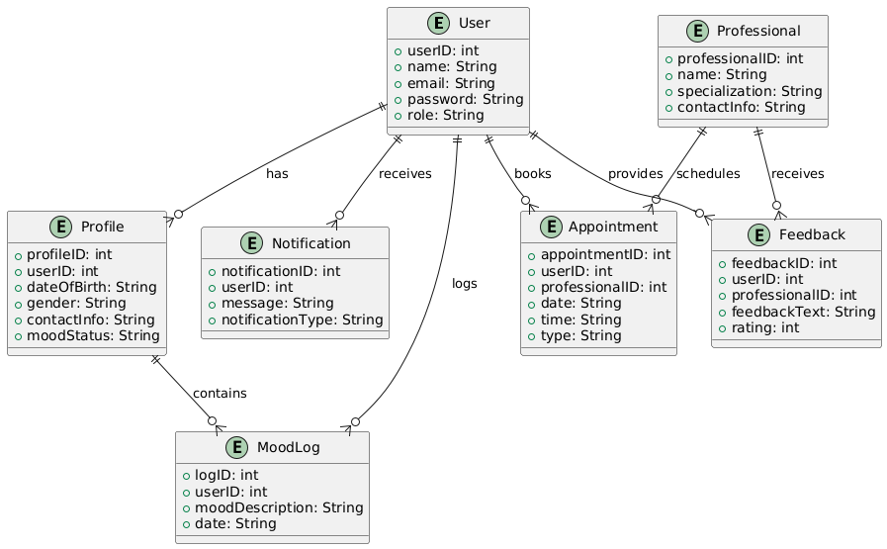

|  |  |
| --- | --- |
| **EX NO:3** | **Draw the entity relationship diagram** |
| **DATE** |

**AIM:**

To Draw the Entity Relationship Diagram for Mind Care Platform.

**ALGORITHM:**

Step 1: Mapping of Regular Entity Types

Step 2: Mapping of Weak Entity Types

Step 3: Mapping of Binary 1:1 Relation Types

Step 4: Mapping of Binary 1:N Relationship Types.

Step 5: Mapping of Binary M:N Relationship Types.

Step 6: Mapping of Multivalued attributes.

**INPUT:**

Entities

Entity Relationship Matrix

Primary Keys

Attributes

Mapping of Attributes with Entities

**Result:**

**ZERO LEVEL:**

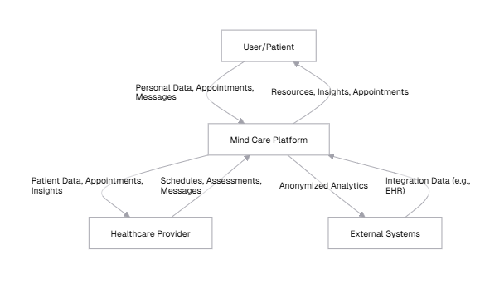

**FIRST LEVEL:**

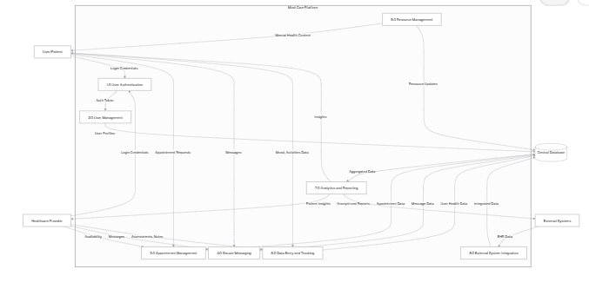

|  |  |
| --- | --- |
| **EX NO:4** | **Draw the data flow diagrams at level 0 and level 1** |
| **DATE** |

**AIM:**

To Draw the Data Flow Diagram for Mind Care Platform and List the Modules in the

Application.

**ALGORITHM:**

1. Open the Visual Paradigm to draw DFD (Ex.Lucidchart)

2. Select a data flow diagram template

3. Name the data flow diagram

4. Add an external entity that starts the process

5. Add a Process to the DFD

6. Add a data store to the diagram

7. Continue to add items to the DFD

8. Add data flow to the DFD

9. Name the data flow

10. Customize the DFD with colours and fonts

11. Add a title and share your data flow diagram

**INPUT:**

Processes

Datastores

External Entities

**Result:**

**SAMPLE OUTPUT:  
  
USE CASE DIAGRAM:**

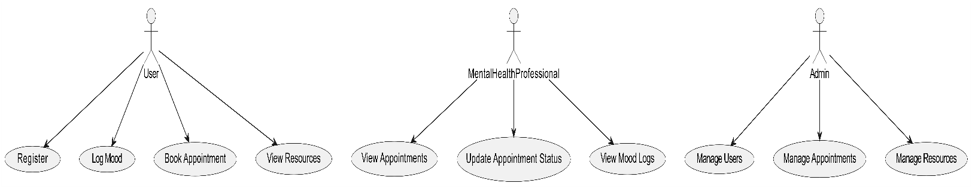

|  |  |
| --- | --- |
| **EX NO:5** | **Draw use case diagram** |
| **DATE** |

**AIM:**

To Draw the Use Case Diagram for Mind Care Platform.

**ALGORITHM:**

Step 1: Identify Actors

Step 2: Identify Use Cases

Step 3: Connect Actors and Use Cases

Step 4: Add System Boundary

Step 5: Define Relationships

Step 6: Review and Refine

Step 7: Validate

**INPUTS:**

Actors

Use Cases

Relations

**Result:**

**SAMPLE OUTPUT:  
  
ACTIVITY DIAGRAM:**

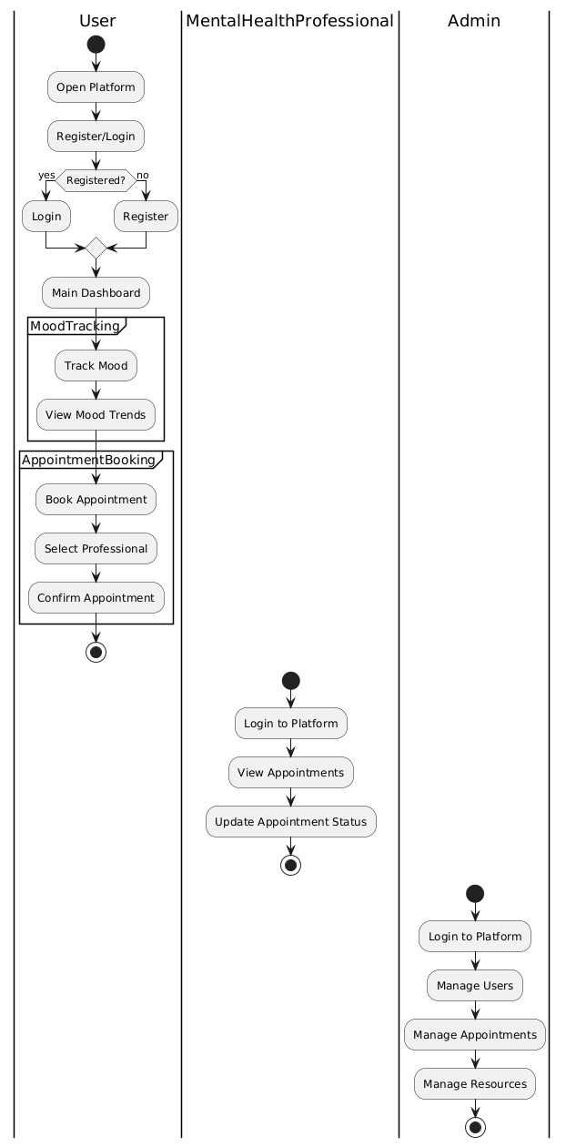

|  |  |
| --- | --- |
| **EX NO:6** | **Draw activity diagram of all use cases.** |
| **DATE** |

**AIM:**

To Draw the activity Diagram for Mind Care Platform.

**ALGORITHM:**

Step 1: Identify the Initial State and Final States

Step 2: Identify the Intermediate Activities Needed

Step 3: Identify the Conditions or Constraints

Step 4: Draw the Diagram with Appropriate Notations

**INPUTS:**

Activities

Decision Points

Guards

Parallel Activities

Conditions

**Result:**

SAMPLE OUTPUT:  
  
STATE CHART DIAGRAM:

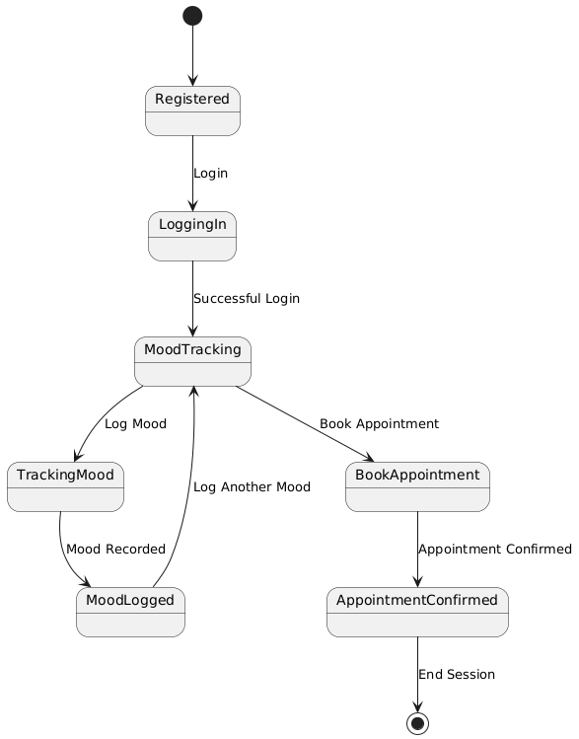

|  |  |
| --- | --- |
| **EX NO:7** | **Draw state chart diagram of all use cases.** |
| **DATE** |

**AIM:**

To Draw the State Chart Diagram for Mind Care Platform.

**ALGORITHM:**

STEP-1: Identify the important objects to be analysed.

STEP-2: Identify the states.

STEP-3: Identify the events.

**INPUTS:**

Objects

States

Events

**Result:**

**SAMPLE OUTPUT:  
  
SEQUENCE DIAGRAM:**

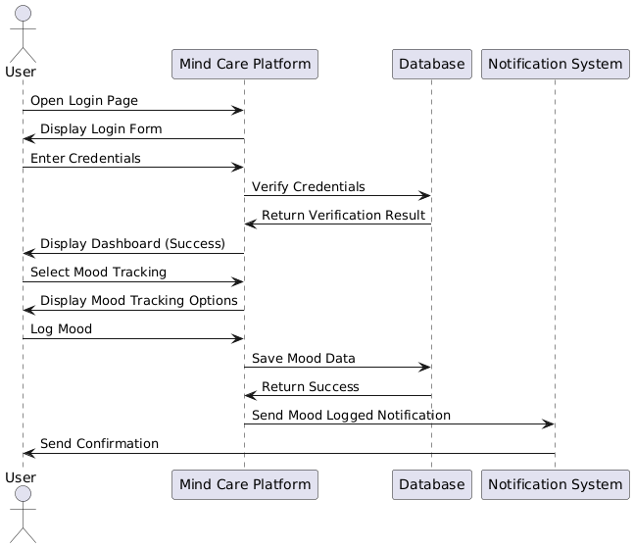

|  |  |
| --- | --- |
| **EX NO:8** | **Draw sequence diagram of all use cases.** |
| **DATE** |

**AIM:**

To Draw the Sequence Diagram for Mind Care Platform.

**ALGORITHM:**

1. Identify the Scenario

2. List the Participants

3. Define Lifelines

4. Arrange Lifelines

5. Add Activation Bars

6. Draw Messages

7. Include Return Messages

8. Indicate Timing and Order

9. Include Conditions and Loops

10. Consider Parallel Execution

11. Review and Refine

12. Add Annotations and Comments

13. Document Assumptions and Constraints

14. Use a Tool to create a neat sequence diagram

**INPUTS:**

Objects taking part in the interaction.

Message flows among the objects.

The sequence in which the messages are flowing.

Object organization.

**Result:**

**SAMPLE OUTPUT:  
  
COLLABORATION DIGRAM:**

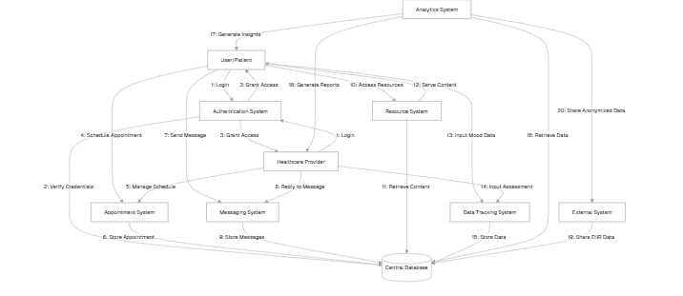

|  |  |
| --- | --- |
| **EX NO:9** | **Draw collaboration diagram of all use cases** |
| **DATE** |

**AIM:**

To Draw the Collaboration Diagram for Mind Care Platform.

**ALGORITHM:**

Step 1: Identify Objects/Participants

Step 2: Define Interactions

Step 3: Add Messages

Step 4: Consider Relationships

Step 5: Document the collaboration diagram along with any relevant

explanations or annotations.

**INPUTS:**

Objects taking part in the interaction.

Message flows among the objects.

The sequence in which the messages are flowing.

Object organization.

**Result:**

**SAMPLE OUTPUT:  
  
CLASS DIAGRAM:**

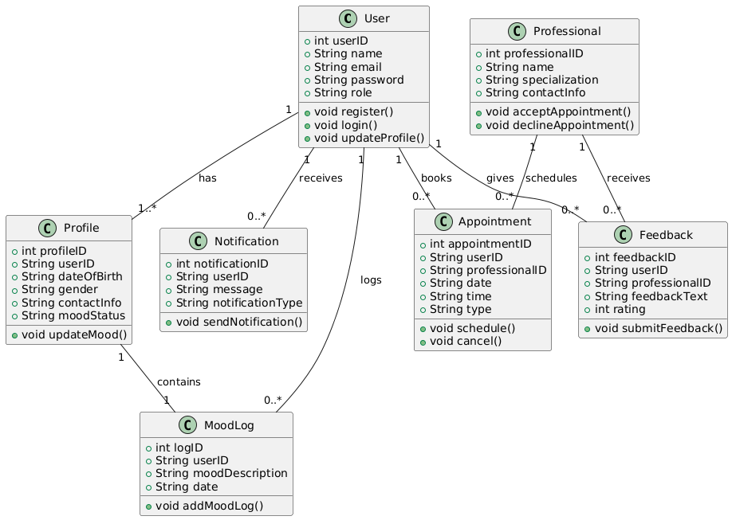

|  |  |
| --- | --- |
| **EX NO:10** | **Assign objects in sequence diagram to classes and make class diagram.** |
| **DATE** |

**AIM:**

To Draw the Class Diagram for Mind Care Platform.

**ALGORITHM:**

1. Identify Classes

2. List Attributes and Methods

3. Identify Relationships

4. Create Class Boxes

5. Add Attributes and Methods

6. Draw Relationships

7. Label Relationships

8. Review and Refine

9. Use Tools for Digital Drawing

**INPUTS:**

1. Class Name

2. Attributes

3. Methods

4. Visibility Notation

**Result:**

**OUTPUT:**

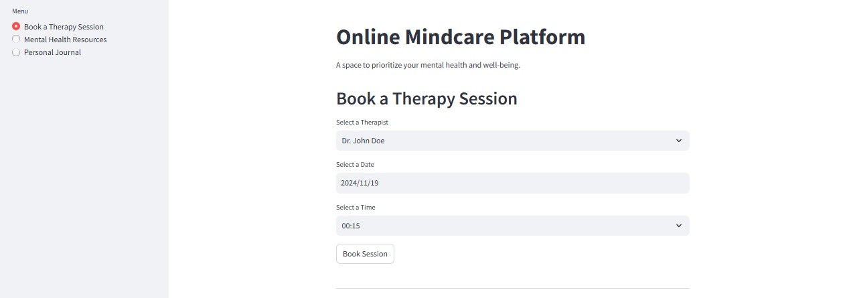

|  |  |
| --- | --- |
| **EX NO:11** | **Mini Project- MindCare Platform** |
| **DATE** |

**Aim:**

The primary aim of this mini-project is to develop a secure and user-friendly **Mind Care Platform** that helps users track their mental health, schedule appointments with professionals, and receive tailored resources. By utilizing MySQL for reliable data storage and a responsive web interface for seamless interaction, we aim to provide a platform that promotes mental well-being, offers confidentiality, and encourages user engagement with mental health professionals.

**Algorithm:**

1. Initialize session states for bookings and journal_ entries.
2. Display the title and menu options: "Book a Therapy Session", "Mental Health Resources", and "Personal Journal".
3. In the "Book a Therapy Session" section, allow the user to select a therapist, date, and time, and store the session details.
4. In the "Mental Health Resources" section, provide a list of resources with links and descriptions.
5. In the "Personal Journal" section, allow users to write and save their journal entries.
6. Display saved journal entries and therapy session bookings.
7. Provide success or error messages based on user actions (e.g., saving a journal entry or booking a session).
8. Include a footer with a link to the Streamlit website.

**Program**:

import streamlit as st

import pandas as pd

# Initialize session state for therapy bookings and journal entries

if 'bookings' not in st.session_state:

st.session_state.bookings = []

if 'journal_entries' not in st.session_state:

st.session_state.journal_entries = []

# Application title

st.title("Online Mindcare Platform")

st.write("A space to prioritize your mental health and well-being.")

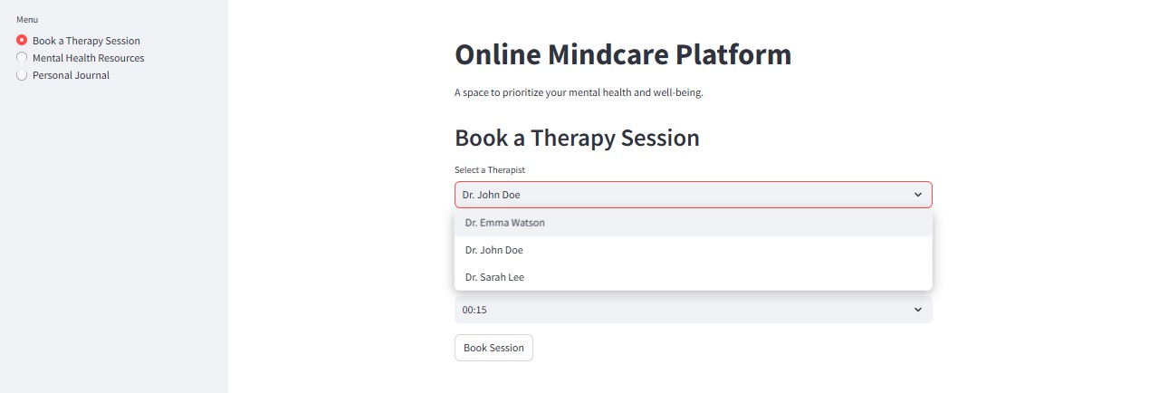

# Sidebar menu

menu = st.sidebar.radio("Menu", ["Book a Therapy Session", "Mental Health Resources", "Personal Journal"])

# Book Therapy Session Section

if menu == "Book a Therapy Session":

st.header("Book a Therapy Session")

therapist = st.selectbox("Select a Therapist", ["Dr. Emma Watson", "Dr. John Doe", "Dr. Sarah Lee"])

date = st.date_input("Select a Date")

time = st.time_input("Select a Time")

if st.button("Book Session"):

st.session_state.bookings.append({

"Therapist": therapist,

"Date": str(date),

"Time": str(time),

})

st.success(f"Session booked with {therapist} on {date} at {time}!")

# Display current bookings

if st.session_state.bookings:

st.subheader("Your Booked Sessions")

df = pd.DataFrame(st.session_state.bookings)

st.table(df)

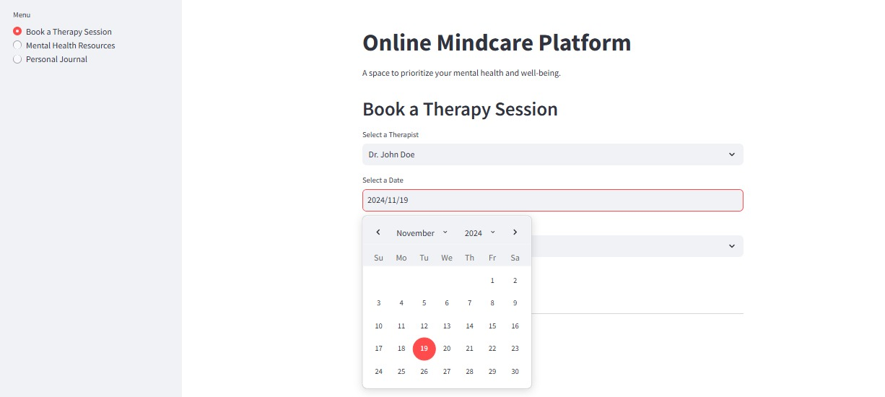

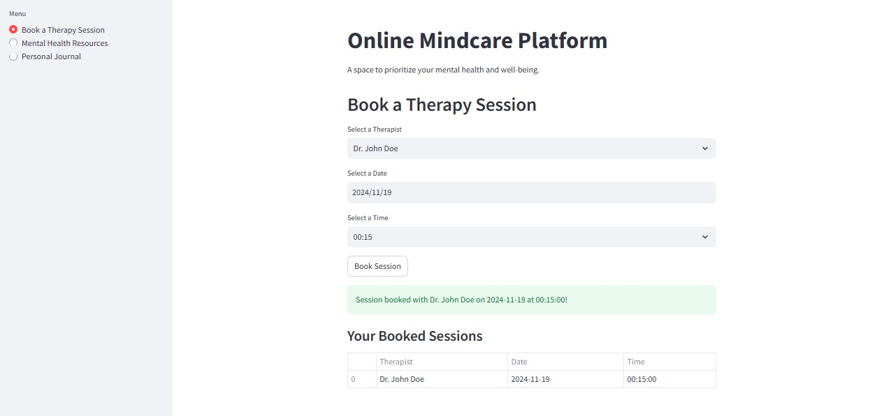

# Mental Health Resources Section

elif menu == "Mental Health Resources":

st.header("Mental Health Resources")

resources = [

{"Title": "Mindfulness Basics", "Link": "https://www.mindful.org", "Description": "Learn the basics of mindfulness and how to incorporate it into your daily life."},

{"Title": "Managing Anxiety", "Link": "https://www.anxiety.org", "Description": "Resources and exercises to help manage anxiety effectively."},

{"Title": "Guided Meditation", "Link": "https://www.headspace.com", "Description": "Explore guided meditation sessions for relaxation and focus."},

]

for resource in resources:

st.markdown(f"### [{resource['Title']}]({resource['Link']})")

st.write(resource["Description"])

# Personal Journal Section

elif menu == "Personal Journal":

st.header("Personal Journal")

journal_entry = st.text_area("Write your thoughts here")

if st.button("Save Entry"):

if journal_entry.strip():

st.session_state.journal_entries.append(journal_entry)

st.success("Journal entry saved!")

else:

st.error("Cannot save an empty entry.")

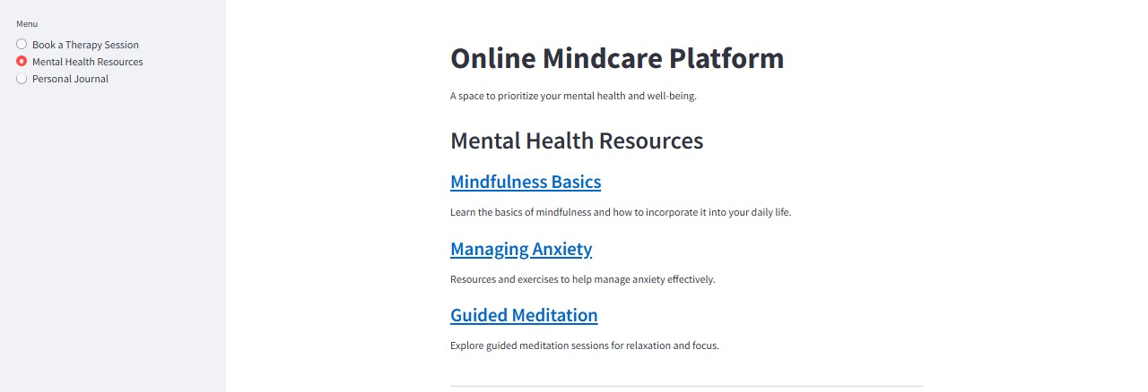

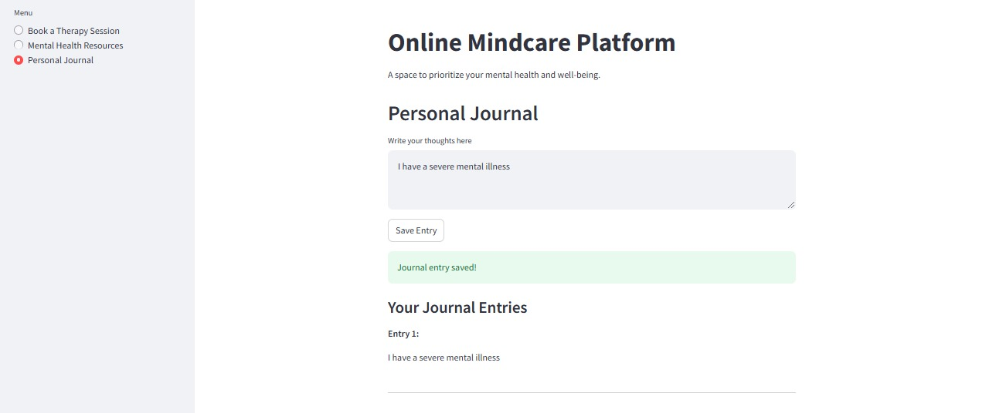

# Display saved entries

if st.session_state.journal_entries:

st.subheader("Your Journal Entries")

for i, entry in enumerate(st.session_state.journal_entries, 1):

st.markdown(f"*Entry {i}:*")

st.write(entry)

st.markdown("---")

# Footer

st.markdown("---")

st.markdown("Powered by [Streamlit](https://streamlit.io)")

`

### Conclusion:

The Mind care Platform provides a user-friendly, secure, and holistic approach to mental health management. By offering features such as therapy session booking, mood tracking, and a personal journal, it empowers individuals to prioritize their mental well-being. The platform's integration of resources and session management enhances accessibility to mental health support, promoting greater awareness and engagement. This project showcases how technology can be utilized to support and improve mental health care, fostering a proactive approach to well-being.